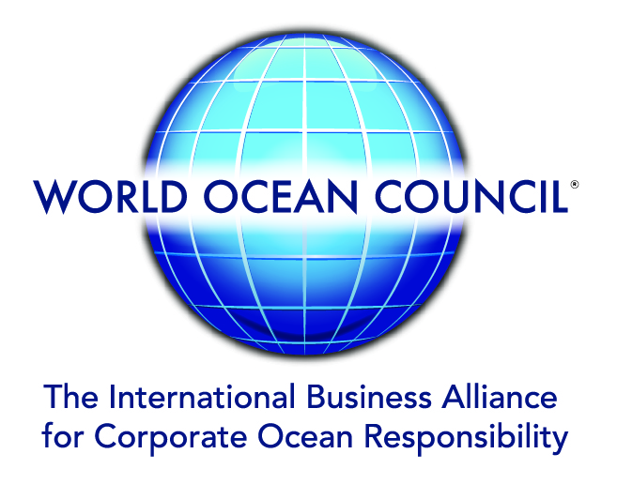

News Release
“FROM ICEBREAKERS INTO CLASSROOMS – OPPORTUNITIES FOR EDUCATORS AND SCIENTISTS”: APECS-ARICE WEBINAR

WOC Working to Advance Arctic Opportunities for Educators and Scientists: APECS-ARICE Webinar, 5 May

1 May 2020

The World Ocean Council (WOC) invites interested parties to the webinar “From Icebreakers into Classrooms – Opportunities for Educators and Scientists”, 5 May at 14:00-15:30 (GMT). The event is organized by the Association of Polar Early Career Scientists (APECS) and the ARICE Project, for which the WOC is the industry organization partner.

In September 2019, German icebreaker Polarstern and Russian research vessel Akademik Fedorov set sail for the Central Arctic sea ice. With the aim to collect data around the coupled Arctic climate system, Polarstern will drift through the Arctic for an entire year as part of the MOSAiC Project.

MOSAiC education and outreach activities aim to create visibility of field research and awareness for globally important topics of Arctic change. Training of early career researchers is being reinforced by the MOSAiC School as well as educational material and data shared within classrooms and online.

During this webinar you will learn about the wealth of learning resources collated by the MOSAiC Expedition. You will be able to put your questions to young researchers and educators on how to use or implement experiments, exercises and personal experiences in classrooms and what you can take away from a massive open online course.

The webinar will be moderated by Josefine Lenz (AWI & APECS). Speakers include:
- Mauro Hermann (MOSAiC Ambassador, ETH Zurich)
- Anne Gold (CIRES, CU Boulder)
- Rainer Lehmann (Polar Educators Germany)
- Falk Ebert (Herder Gymnasium)
- Friederike Krueger (Integrierte Gesamtschule Bothfeld)

Click here to register for the webinar.

For more information, visit https://arice.eu/training/webinars/100-arice-webinar-from-icebreakers-into-classrooms.

Within ARICE, the WOC has been working to ensure regular and sustained interaction between the Arctic science community and industry – by providing the leadership and industry connection to develop an Industry Liaison Panel, whose role will be to engage key companies to be a part of this structured process. WOC is also working to identify key industry stakeholders with operations in the Arctic Ocean, i.e. those who are able to deploy instrumentation or collect environmental data in the region, with the aim of expanding observation capacities in the Arctic.

Recent and Upcoming WOC Outreach and Engagement

21 April, 15:00-16:00 CEST, Online Webinar
SEA20 – Weathering the Storm: COVID 19, Port Cities and Maritime Industries (Panel Speaker)
https://www.sea20.org/read/weathering-the-storm-while-preparing-for-a-leap

19 May, 9:00-10:00 CEST, 20:00-21:00 CEST, Online Webinar
International Union of Marine Insurers (IUMI) – WOC Briefing on the New U.N. Ocean Treaty: Biological Diversity of Areas Beyond National Jurisdiction (BBNJ) (Speaker)

28 June-1 July, STAMFORD, USA
CMA Shipping 2020 (Plenary Speaker on Law of the Sea/BBNJ Treaty)
https://informaconnect.com/cma-shipping/

TBC, NEW YORK
U.N. Law of the Sea, BBNJ Treaty – 4th (Final) Negotiation Session on the international, legally binding instrument under the U.N. Convention on the Law of the Sea re the conservation and sustainable use of marine biological diversity of areas beyond national jurisdiction (BBNJ) (Industry Representative)

TBC, BRUSSELS
4th Meeting of the EU Marine Knowledge Expert Group (Participant)

World Ocean Council (WOC) – The Global Blue Economy Business Organization

The WOC is the international, cross-sectoral alliance for private sector leadership, collaboration and action on ocean sustainability, stewardship and science. Companies from a range of industries worldwide are distinguishing themselves as leaders in “Corporate Ocean Responsibility”, including: shipping, oil and gas, tourism, fisheries, aquaculture, mining, renewable energy, ocean technology and investment.

WOC Members are listed here, a part of the WOC Network of 35,000+ ocean industry stakeholders around the world. The WOC is a registered not-for-profit organization in the US, UK and France.

Contact email: info@oceancouncil.org Web: www.oceancouncil.org

To subscribe to future WOC News or to update your contact information, click here.
To share this issue of WOC News with others (on Facebook, Twitter, etc), click here.

©2020 World Ocean Council | 3035 Hibiscus Drive, Suite 1 Honolulu, HI 96816 USA

