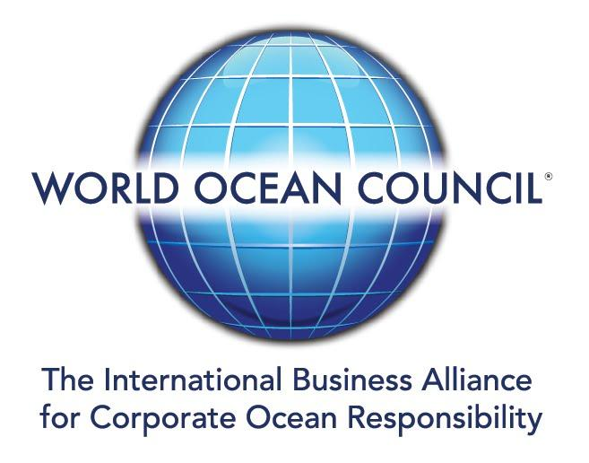

News Release
TEAM ABC JOINS WOC, BRINGING TRAVEL INDUSTRY EXPERIENCE TO OCEAN INVESTMENT PLATFORM

World Ocean Council Welcomes Team ABC – Investor in Travel and Tourism - to the Global Blue Economy Business and Investment Organization

23 April 2021

The World Ocean Council (WOC) is proud to announce that Team ABC, an international venture capital fund that invests in sustainability and digital transformation in the transportation and tourism industries, has joined the WOC to advance sustainable technology for the aviation, aerospace and maritime industries.

Clyde Hutchinson, Partner at Team ABC, stated that, “It is an honor to partner with the World Ocean Council to help further its mission of improving ocean sustainability, stewardship and research. Team ABC actively invests in companies that offer sustainable solutions in land, air and sea travel, and our relationship with the WOC will help grow our ecosystem of startups, scale-ups and corporations looking to innovate the future of travel and transportation.”

Team ABC focuses on finding solutions for challenges in digital transformation and increasing need for sustainability and works with corporates, funding bodies and start-ups to generate, evaluate and support the development of innovative growth concepts. The firm develops early-stage venture funds to focus on early stage companies and help them reach their first major milestones.

By becoming a member of the growing WOC international, multi-industry alliance on ocean sustainable development, Team ABC seeks to advance its position as a leadership company in “Corporate Ocean Responsibility”.

Paul Holthus, WOC Founding President and CEO said: “We are excited to have Team ABC come on board as part of the growing WOC Ocean Investment Platform. Their investment experience in sustainability, technology and innovation in the travel sector brings another dimension to the monthly WOC Ocean Investor Roundtable.“

UPCOMING WOC EVENT

Global Blue Finance Summit (BlueFIN ‘21) – Dates to be determined

Recent and Upcoming WOC Outreach and Engagement

13-16 April, Online event
Island Finance Forum ‘21 (Partner)

15-16 April, Online event
Artificial Intelligence LA - Earth Summit: “Using Technology to Monitor and Protect Oceans and Coastal Communities” (Panellist)

28-30 April, Online event
International Conference on Ocean Energy (ICOE): “The UN Decade of Ocean Science for Sustainable Development: What is it and what does it mean for Marine Energy?” (Plenary Session Moderator)

18-19 May, Online event
Summit4Oceans – Blue Economy: An Opportunity for Sustainability and Economic Growth (Partner, Plenary Speaker)

World Ocean Council (WOC) – The Global Blue Economy Business Organization

The WOC is the international, cross-sectoral alliance for private sector leadership, collaboration and action on ocean sustainability, stewardship and science. Companies from a range of industries worldwide are distinguishing themselves as leaders in “Corporate Ocean Responsibility”, including: shipping, oil and gas, tourism, fisheries, aquaculture, mining, renewable energy, ocean technology and investment.

WOC Members are listed here, a part of the WOC Network of 35,000+ ocean industry stakeholders around the world. The WOC is a registered not-for-profit organization in the US and France.

Contact email: info@oceancouncil.org Web: www.oceancouncil.org

To subscribe to future WOC News or to update your contact information, click here.
To share this issue of WOC News with others (on Facebook, Twitter, etc), click here.

©2020 World Ocean Council | 3035 Hibiscus Drive, Suite 1 Honolulu, HI 96816 USA

